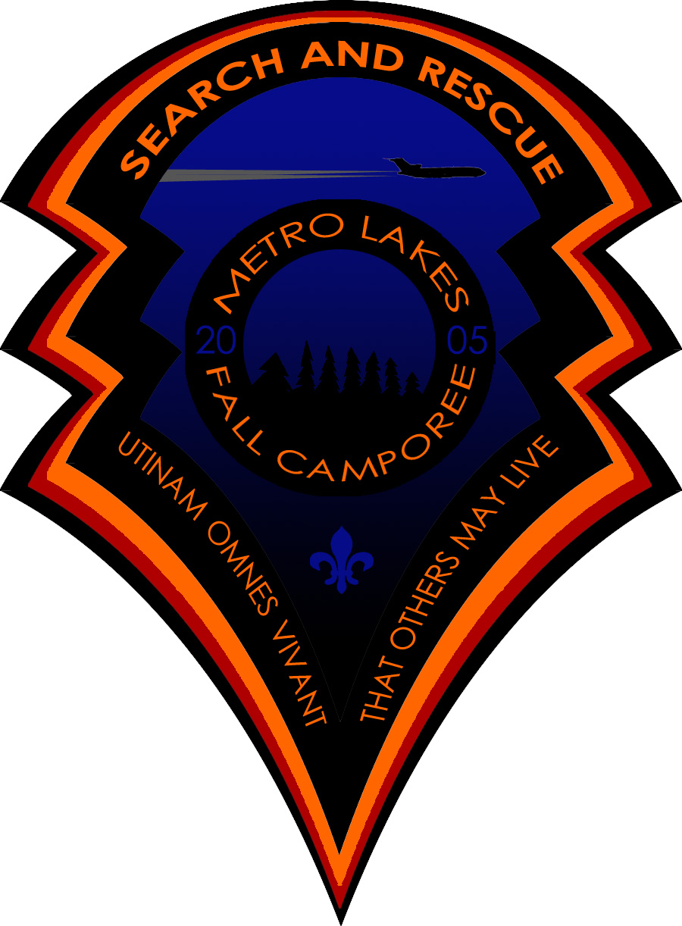

Fall 2005 Camporee

Metro Lakes District
Rum River Campgrounds
September 23, 24,25

Dear Scouts and Scouters,

Your Troop is invited to attend the annual Metro Lakes District Fall Camporee. This year’s theme is “Search and Rescue II”. The Camporee dates are September 23-25.

This registration packet should help you understand what is happening at the Camporee so you can publicize it to your Troop. Activities will include the Search and Rescue airplane crash scenario, escape from a burning building, putting out a fire with a fire extinguisher, water safety 101, and the Emergency Response Vehicle from the Red Cross. Keep reading for more information about each event. We are also planning on having the second year Webelos attend the event so start contacting the Den Leaders now. The second year Webelos (and as many of their parents as we can convince to do it), will be the victims for the plane crash. Please make sure that the Webelos and their parents are wearing old clothes because some of the make up WILL STAIN!

Due to the fun and exciting nature of this Camporee we are highly encouraging all Scouts & Webelos to BRING A FRIEND!! The more people the merrier at this event!!

In addition to the exciting events we have planned this year we are also going to have a food drive like we have had in the past. As usual we will be giving a cup of Root Beer away to each Scout (or Webelos) who brings us two cans of food. The food shelves are always happy to receive the food at this time of year. Unfortunately last fall most of the Scouts never got the word about the food drive so we had to sell the Root Beer instead of giving it away for food. While that doesn’t hurt the budget we would have rather had the cans of food to help feed the hungry kids in the area. Please promote this to the youth in your Troop.

We need your assistance with staffing this event. With many exciting activities planned for the 20 or so Troops and over 350 Scouts and Scouters we need Staff Members! Each Troop is asked to encourage one older Scout, preferably one who is not currently an SPL or PL and who is a member of the OA, to volunteer to work on the Camporee Staff.

We will be doing the annual Order of the Arrow Callout after the campfire on Saturday night. ALL youth members of the OA are encouraged to participate! We have extra sets of regalia that they can use to participate. Anyone wishing to borrow some of our regalia should just stop by Colbert Lodge during dinner and talk with the OA staff at that time.

If there are any adults who would like to assist with the planning and staffing for future Camporees, you can also contact me as fresh ideas are always welcome for these events. Call, Ted McLaughlin, at (612) 845-3062; email at mclaught@visi.com, or John Roemer, District Camporee Chairman, at (612) 788-3496;email at: jroemer@hubmfg.com, if you are interested in being either on staff for either this Camporee, or are interested in helping with planning future Camporees.

I am looking forward to seeing all of you at the Camporee!!!!

Ted McLaughlin
Metro Lakes District Camporee Committee
Program Chair

Table of Contents
Welcome Letter 2
General Information 3
Camporee Policies 4
Event Schedule 5
Patrol Requirements 5
Event Descriptions 6
Registration Form 7
Pre-Registration Form 8

General Information

First Aid
First Aid will be available at Colbert Lodge. However, each Troop should be able to take care of minor injuries. Injuries requiring medical attention should be reported to and attended by the staff at Colbert Lodge. Please have proper medical forms for each person. We will try to have trained medical personnel on staff for this Camporee.

Permission Slips
Every Scout should have a permission slip signed by their parents/guardians giving permission for any medical treatments, hospital visits, etc. These forms should be kept in the campsite and be readily accessible in the event of an emergency. We will not be doing rifle or archery this time so you will not need separate permissions slips for that this year.

Uniforms
Scouts should be in Class “A” uniforms upon arrival, at worship services, Flag Ceremonies, and during the campfire program. During the day on Saturday Scouts may dress in either Class “A” uniforms, or Troop tee-shirts. Patrols should dress consistently. Preference for using the fire extinguishers will be given to Scouts wearing their Class “A” uniforms.

Scouts not in long pants and Scouts with open toed shoes will NOT be allowed to use the fire extinguishers as part of the fire extinguisher demo.

Webelos (and their parents) should wear old grubby clothes during the day on Saturday, because some of the makeup used to give you those horrific injuries will stain clothes.

Fees
The cost for the Camporee this year is $8.00. This includes a nifty patch, camp fees, prizes, cracker-barrel, awards, and other assorted supplies and equipment. Not too bad for a great weekend. The cost for Webelos and their family members is $4.00.

Food for Webelos & Families
Because all Webelos & their families will need to be at the Weaver Lodge at 7:00am for their makeup calls ☺, the Camporee staff will take care of feeding them both Saturday breakfast and lunch. Troops will have to make arrangements to feed the Webelos that register with them dinner on Saturday night as well as breakfast on Sunday morning.

Camporee Policies

The following rules were made to help us have a successful and safe camping experience. It is the responsibility of the adults in charge to see that their Scouts know and understand these rules. Anyone caught violating them may be asked to leave the camp.

Vehicles: Speed limit is 15 mph

No passengers in back of truck or trailer. Vehicles limited to main roads and parking areas only. Trailers may be left in a campsite but the vehicles should be moved to the parking lots.

Fires: Campfires are allowed in designated spots.

All liquid fuels must be used with adult supervision.

NO CAMPFIRE MAY BE LEFT UNATTENDED!!
NO FIRES OUTSIDE OF FIRE RINGS!!

Firearms: Firearms, explosives, and fireworks are prohibited.

Conservation: Please conserve our natural resources. No digging, trenching, or raking.

ABSOLUTELY no cutting of brush or standing timber is allowed. The Ranger will assess a
$100 per inch wide fine for cutting timber.

Adults: At least one responsible adult (21 or older) must be in camp at all times, with a minimum of 2 adults.

Knives: NO straight bladed knives are allowed in camp.

Lights out: Scouts are not allowed out of their site after lights out with the exception of to and from the latrine.

PLEASE respect others during lights out. Scouters are asked to bring roaming Scouts to the headquarters after lights out.

Radios: No radios, stereos, tape players, headsets, etc. are allowed in camp.

Swimming: Any Scout caught swimming or wading in the lakes or river without permission will be asked to leave camp.

Event Schedule
Friday:
7:00 - 9:00 Check-in at Colbert Lodge
9:00 – 10:00 Crackerbarrel for Scoutmasters. We would like at least one adult and the SPL from each Troop. (There will be NO SPL breakfast in the morning).
10:30 Lights out

Saturday:
7:00 Reveille – All Webelos and their parents report to Weaver Lodge.
9:00 Flag Raising
9:30 Morning events kick off
11:30 or 12:00 Lunch – There are two different start times for lunch
1:00 or 1:30 First afternoon events kick off
3:45 Firemen rappelling from helicopter demo at the crash site
5:00 Afternoon events end
1:00-6:00 Trading post open at Colbert Lodge
5:00-7:30 Dinner
7:30 Non-Denominational Service
8:00 Flag Retreat
8:15 Campfire
9:30 Order of the Arrow Callout
10:00 Lights Out

Sunday:
7:00 Reveille
7:30-9:00 Breakfast and break camp
9:00-10:00 Check out and campsite inspections
10:30 All units should be out of Camp. See You At The Spring Camporee!!

Patrol Requirements
Each Patrol will compete in all events. The Patrol will be issued an Event Card indicating the location and time of each event. The SPL will receive the Event Card at the flag raising Saturday morning.. All members of a Patrol must stay together at all times.

There will be water located at the event sites, however, Scouts will be required to have their own bottle or cup. Drinking directly from the water jugs will not be allowed.

Each Troop should also plan for a skit for the campfire – it helps to have this planned out in advance.

Each Patrol will need come to the Plane Crash Scenario with a home made stretcher. This stretcher will be used to carry victims of the plane crash around. The stretcher will need to be ‘rated’ for carrying larger adults as well as Webelos.

The Search and Rescue II Events:

Search and Rescue: Imagine your Troop is canoeing along the glassy waters of the Boundary Waters Canoe Area. You are enjoying the trip of a lifetime amongst the scenic wonders of northern Minnesota, when suddenly you see an airplane in coming out of the sky with flames trailing behind it. It crashes not far from where you are. Your Troop paddles frantically towards where it went down, along the way finding other canoeists like yourselves who are rushing to the scene of the disaster. The whole time you are paddling you are wondering to yourself, “where is the nearest fire department?” You know that it is going to be up to you and your fellow Scouts to find the victims and to treat them as best you can. If you are lucky you might have helicopters coming soon, but for now it’s just you……
The ROOF, the ROOF, the ROOF is on FIRE!!! What do you do when you wake up in the middle of the night and the roof really is on fire?? Imagine yourself trapped in a room filled with smoke trying to find your way outside. What do you do? How do you see? Can you survive???
Fire Extinguishers 101: Everyone has seen a fire extinguisher, hopefully you have at least one around the house. But do you REALLY know how to use one? Could you put out a fire if you had to? Depending on how many fire extinguishers we are able to come up with, (as well as a few other variables such as how much the Scouts are paying attention to the safety briefings) we will allow as many Scouts as possible to actually put out a fire using a fire extinguisher. Preference for using the fire extinguishers will be given to those Scouts in Class “A” uniform! No one in shorts or sandals will be allowed to put out fires.
Water Safety 101: The Anoka County Water Patrol and the United States Coast Guard will be doing demonstrations (with hands on stuff as well) of the proper wearing and sizing of personal flotation devices (PFD). Remember, one size does NOT fit all. There will also be demonstrations of what to do, (and more importantly) what not to do, and how to do it when it comes to surviving in the water. In the Land of 10,000 Lakes, this is an event that no one should miss.
Helicopter Rappelling – This is a demonstration only event (as much as the Scouts would want to rappel off a helicopter we can’t let them). We will have a couple of St Paul Firemen rappelling off of the MN State Patrol’s helicopter. This will be to simulate how rescue crews get into hard to reach areas.

Food Donations – This is complicated event. It involves every Scout in the Patrol getting two cans of food and bringing them to Colbert lodge. Once at the lodge the Scout will hand his two cans of food over to one of the Staff members there. After receiving his just rewards he will also have the opportunity to purchase other items from the Trading Post.

Score: Every Scout is a Winner!! Each one (who brings two cans of food) gets a free glass of Root Beer as a prize!!

2005 Metro Lakes Fall Camporee Registration Form

See Next page for Pre-Registration Form, please bring this form with you to campout. It should be filled out and turned in by the end of the cracker-barrel Friday night.

Troop _________________
Scoutmaster _______________________________
SPL ______________________________________
Name of Patrols (& how many Scouts are in each)_______________________________________
(We NEED the names of the Patrols, and how many Scouts are in each, FRIDAY night!)

Scouts: (Please circle the names of Webelos & their parents)
1 _____________________ 2 _____________________ 3_______________________

4 _____________________ 5 _____________________ 6_______________________

7 _____________________ 8 _____________________ 9_______________________

10 ____________________ 11 ___________________ 12 ______________________

13 ____________________ 14 ____________________ 15______________________

16 ____________________ 17 ____________________ 18______________________

19 ____________________ 20 ____________________ 21______________________

22 ____________________ 23 ____________________ 24______________________

25 ____________________ 26 ____________________ 27______________________

27 ____________________ 28 ____________________ 29______________________

Adults:
1 _____________________ 2 _____________________ 3_______________________

4 _____________________ 5 _____________________ 6_______________________

7 _____________________ 8 _____________________ 9_______________________

Total Participation ______________ Payment Method:

Registration Fee $8.00, ($4.00 per circled name):_________ Troop Check ______

Late Fee _________________________________________ Personal Check______
(if applicable $25) Cash _______

Total Due _______________

2005 Metro Lakes Fall Camporee Pre-Registration Form

This form is to be sent to the Northern Star Council West Service Center prior to September 15th. Any registration forms received after that will be assessed a $25 dollar late fee.

If you have any question as to why we have late fees, ask Ted McLaughlin about being at Rainbow foods at 2am Saturday morning during the 1999 Spring Camporee making additional copies of event forms to cover the Troops who showed up unexpectedly.

Troop _____________________________________________________________

Scoutmaster_________________________________________________________

Estimated # of boys___________________________________________________

Estimated # of Adults__________________________________________________

Total amount paid for Scouts ($8 per person)________________________________

Estimated number of Webelos (& family members), ($4 per person)______________

Total amount pre-paid for the Camporee ____________________________________

Refunds will be made if the expected attendance is not met. Troops who have more show up than pre-registered will not be charged any fees over the registration costs.

Forms should be mailed to:
Northern Star Council, BSA
Attn: Metro Lakes 2005 Fall Camporee
5300 Glenwood Ave
Golden Valley, MN 55422

Parking Permit
Metro Lakes Districts Fall Camporee
Valid from 5:00 PM Sep 23 through 09:45 AM Sep 25, 2005
Display prominently on vehicle’s dashboard so that it can easily be read from outside your vehicle. If your vehicle needs to be moved, we must be able to contact you expeditiously! Make copies as needed for all vehicles associated with your unit and fill them out before your arrival at Rum River.

Your Name:

Unit Number:

This licenses the holder to park one vehicle in this area entirely at the vehicle owner’s risk. Lock your vehicle. Properly secure your property. (Do not unnecessarily tempt the Dark Side of the Force!) Licensor declares itself not responsible for fire, theft, or damage to the vehicle or to any and all articles left therein. Only a license is granted hereby and no bailment is granted. Management reserves the right to move your vehicle.
------------------------------------------------------------------------------------------------------------------------------------------------------------------------------
Parking Permit
Metro Lakes Districts Fall Camporee
Valid from 5:00 PM Sep 23 through 09:45 AM Sep 25, 2005
Display prominently on vehicle’s dashboard so that it can easily be read from outside your vehicle. If your vehicle needs to be moved, we must be able to contact you expeditiously! Make copies as needed for all vehicles associated with your unit and fill them out before your arrival at Rum River.

Your Name:

Unit Number:

This licenses the holder to park one vehicle in this area entirely at the vehicle owner’s risk. Lock your vehicle. Properly secure your property. (Do not unnecessarily tempt the Dark Side of the Force!) Licensor declares itself not responsible for fire, theft, or damage to the vehicle or to any and all articles left therein. Only a license is granted hereby and no bailment is granted. Management reserves the right to move your vehicle.
---------------------------------------------------------------------------------------------------------------------------------------------------------------------------
Parking Permit
Metro Lakes Districts Fall Camporee
Valid from 5:00 PM Sep 23 through 09:45 AM Sep 25, 2005
Display prominently on vehicle’s dashboard so that it can easily be read from outside your vehicle. If your vehicle needs to be moved, we must be able to contact you expeditiously! Make copies as needed for all vehicles associated with your unit and fill them out before your arrival at Rum River.

Your Name:

Unit Number:

This licenses the holder to park one vehicle in this area entirely at the vehicle owner’s risk. Lock your vehicle. Properly secure your property. (Do not unnecessarily tempt the Dark Side of the Force!) Licensor declares itself not responsible for fire, theft, or damage to the vehicle or to any and all articles left therein. Only a license is granted hereby and no bailment is granted. Management reserves the right to move your vehicle.

